IFT 598: Middleware Prog & Database Sec (2022 Fall)

M Module 8: Assignment Final Project

Name: Jyoshnapriya buddhi

Class: 2022Fall-P-IFT458-IFT598-82341-82345

Date: 12-02-2022

**Aim:**

To create a fully functional full stack web application using technologies like NodeJS, Express JS, MongoDB.

**Goal:**

The main goal of the project is to create a fully functional loan application with great database design for creating user and loans. With authentication included, the user must be properly authenticated using JWT tokens before creating a new user or registering a new loan account. The user interface should be responsive and good looking.

**Features of the project:**

* Home page
* User signup
* User login
* Landing page
* Loan Account creation
* Loan display

**RISK statements:**

* Browser support incompatibility might result in loss of UI elements in the website due to failure to load libraries.
* If many users try to access the website, the site might crash due to increased user traffic. We hosted the website with limited resources.
* The database is completely dependent on MongoDB ATLAS so if their server goes down so does our website.
* The front end code is written using basic HTML, CSS and Java script so anyone can inspect the webpage and copy the code.

**Software Requirement:**

* Development: Visual Studio Code
* Database: Mongo DB
* Cloud database management: MongoDB Atlas
* Flow diagram: Lucid Chart
* Tests: Postman Client

**Security Concerns:**

* We have basic flow for signup and login. The URLs can be also encrypted for added security.
* Introducing two-factor authentication or OAuth 2.0 authorization gives more login confidence for the user.

**Design Concerns:**

* The webpage is not designed for tablet or mobile phones and it will work with only desktops scaled full screen.
* The User interface can be even better than the one which we are using with the help of libraries like Bootstrap, SAAS etc.

**Estimate : (~25 days)**

* Initializing project and main driver code: 2 days
* Designing the database schema: 5 days
* Deciding routes: 2 days
* User Controller: 3 days
  + Create User: 1 day
  + Login User: 1 day
  + Get all users, landing page: 1 days
* Loan Controller: 3 days
  + Creating a new loan: 1 day
  + Loan list view: 1 day
  + Landing page: 1 day
* Auth Controller: 3 days
  + Signup: 1 day
  + Login: 1 day
  + Protect: 1 day
* Creating PUG files: 6 days
  + Login: 1 day
  + Signup: 1 day
  + Home page: 1 day
  + Landing page: 1 day
  + Create loans and loan list : 1 day
  + Link all the pug files with the route methods
* Test the complete project using postman: 1 day

**Progress from Module 1 to Module 8**

Module 1: Learnt about creating new project and installing node libraries. Created the foundation for the project.

Module 2: Created a GitHub profile and basic java script functions for the project.

Module 3: Create entity models for loans and user.

Module 4: Define Model Schemas for loan and user and design the database. Test the routes with postman client.

Module 5: Create authentication for user and loan routes. Add functions to create and decode JWT token to give access to web pages.

Module 7: Creating PUG files for user login, sign up, home and landing page and linking them with our methods to render when called upon.

**New User UI:**

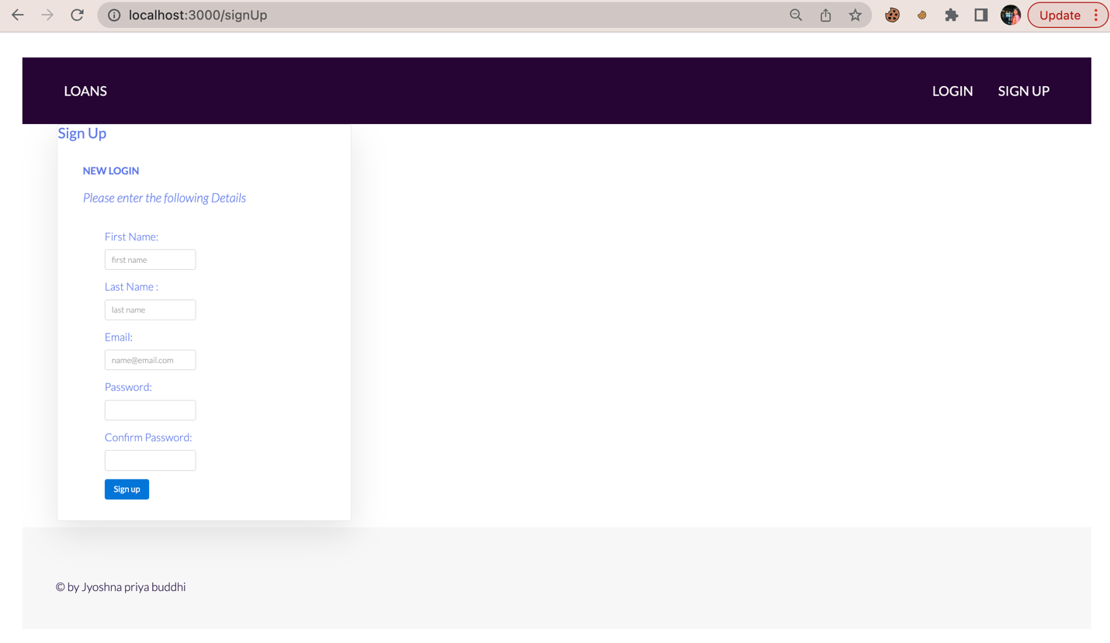

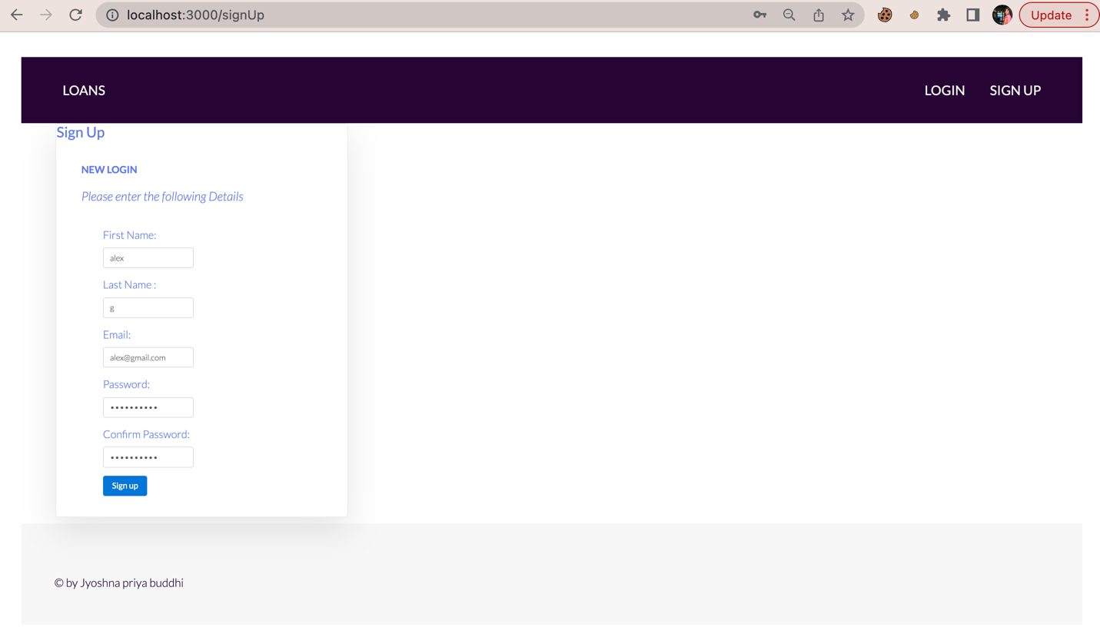

**Login User UI**

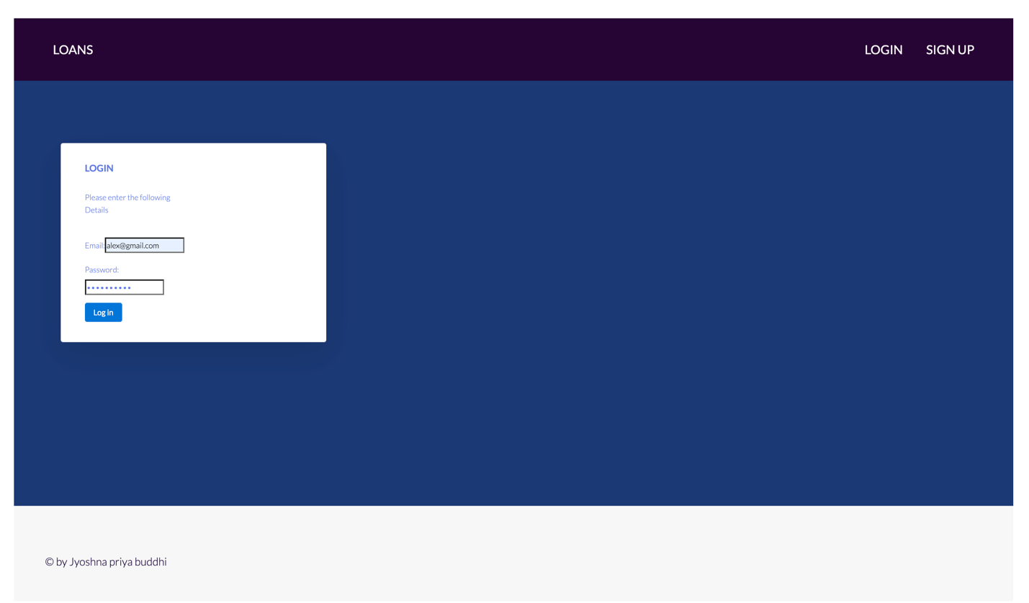

**Landing page**

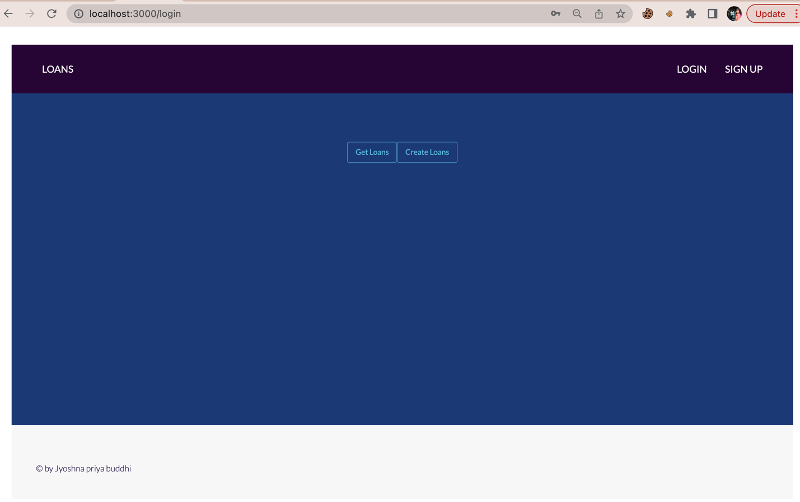

**Home page**

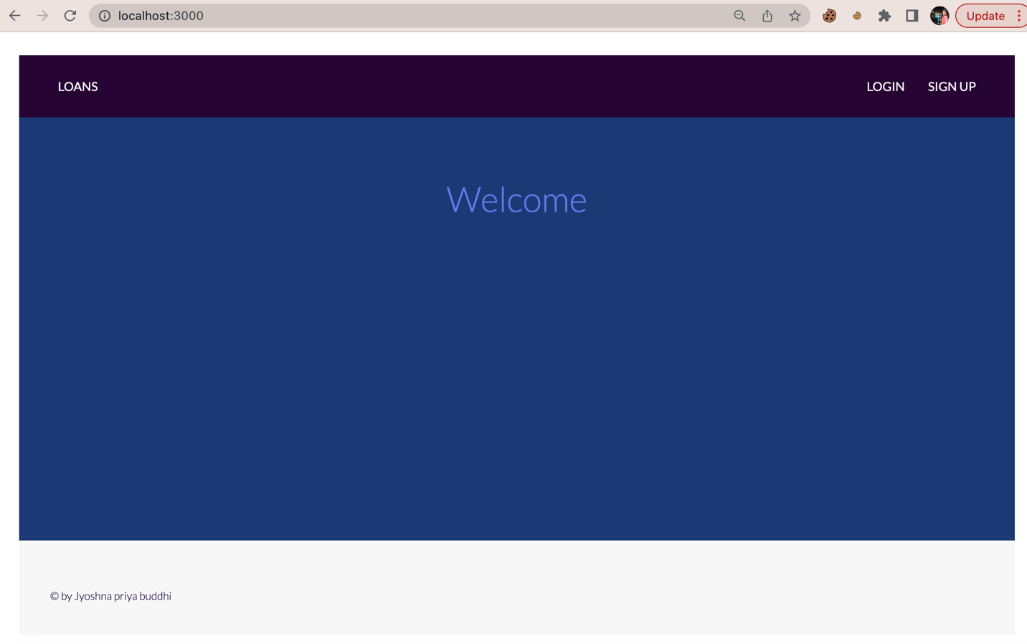

**Create account UI**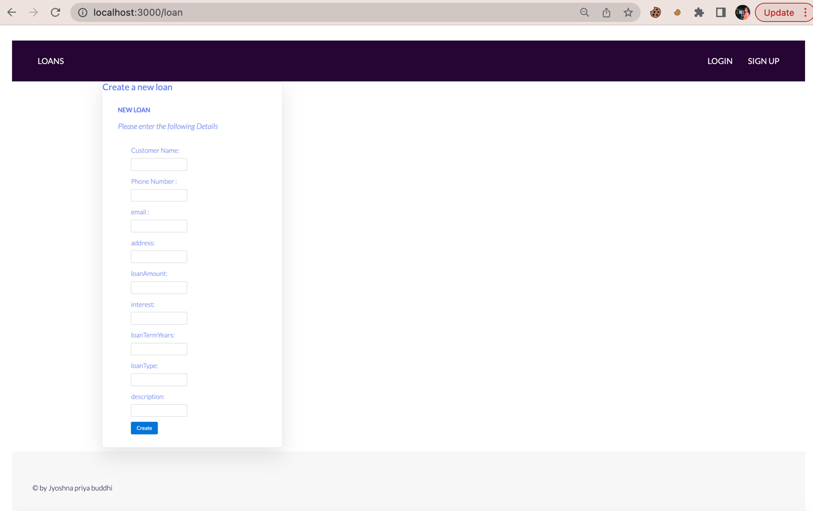

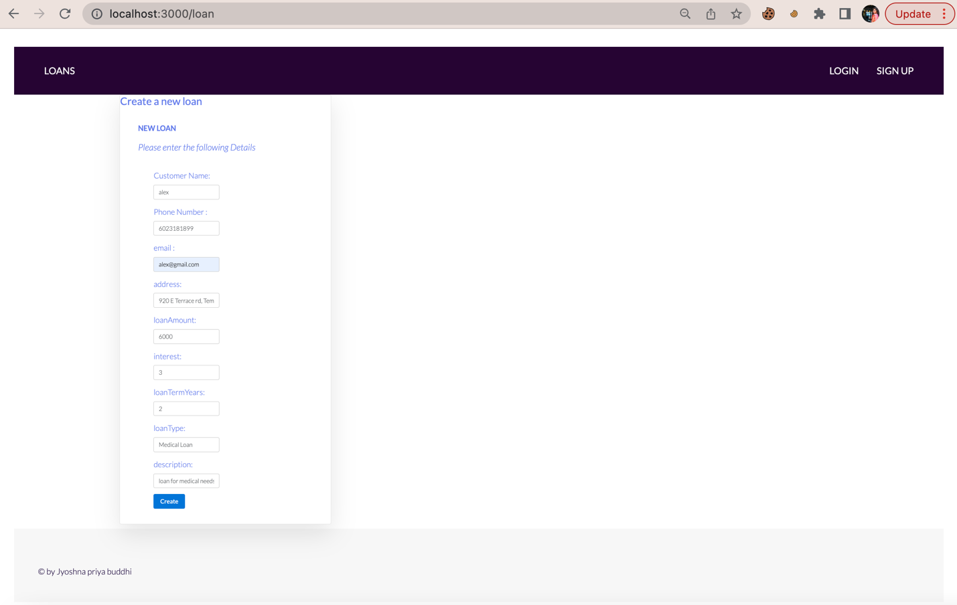

**List Accounts UI**

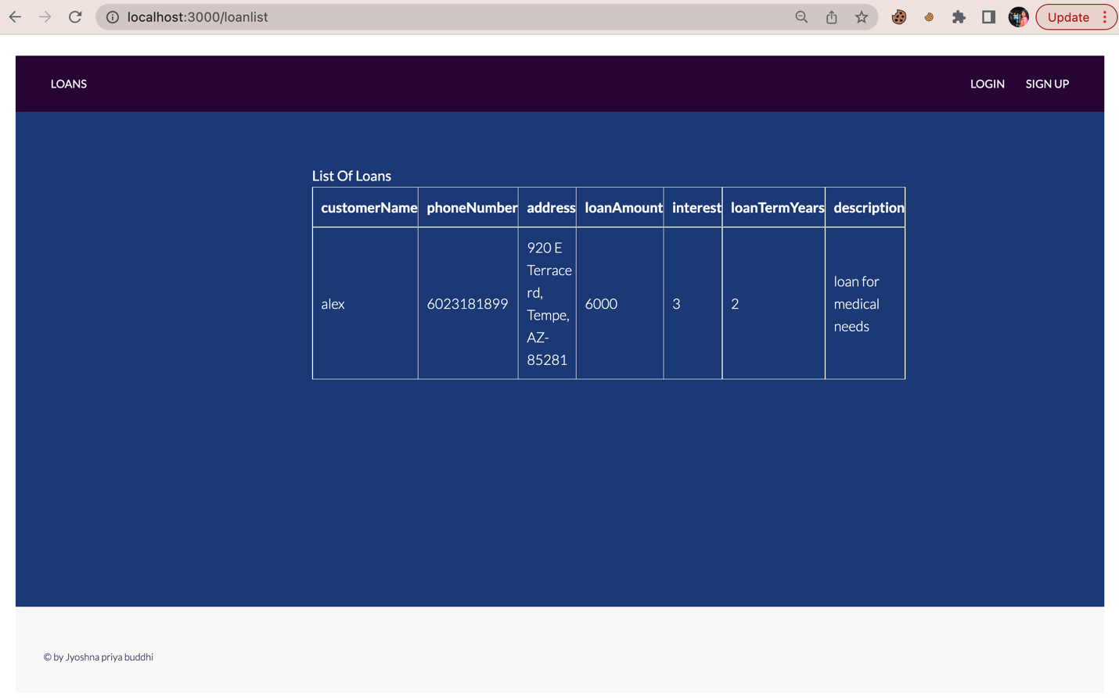

**Route new User, login user, new loans and list loans**

Loan Routes

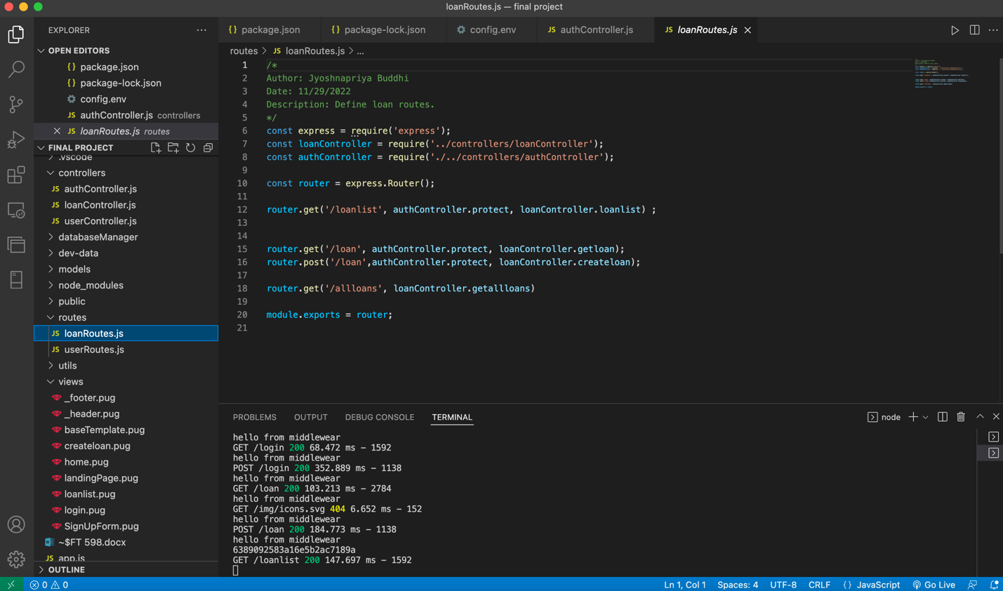

User Routes

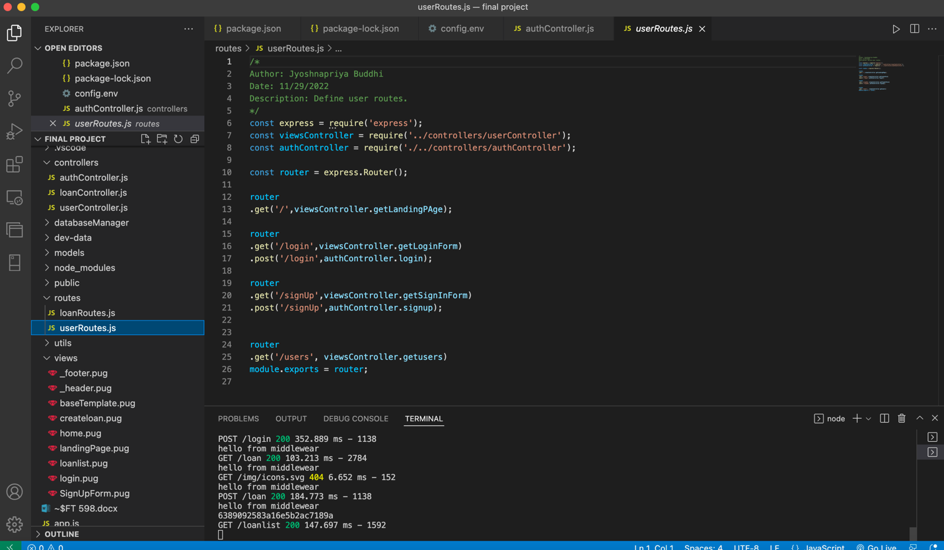

Controllers

AuthController

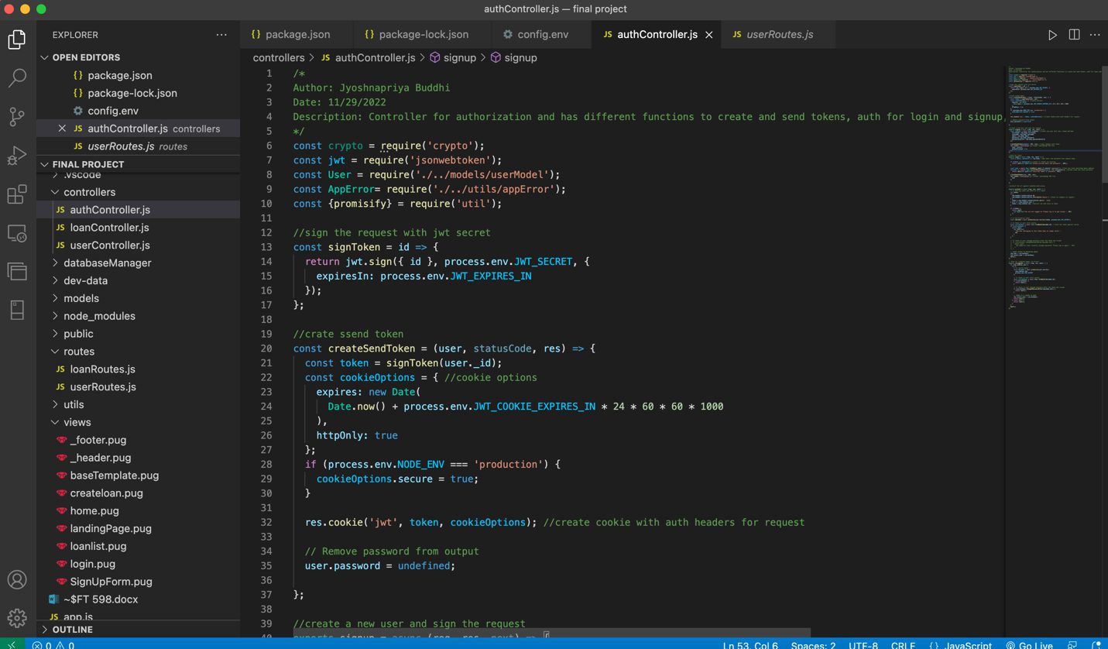

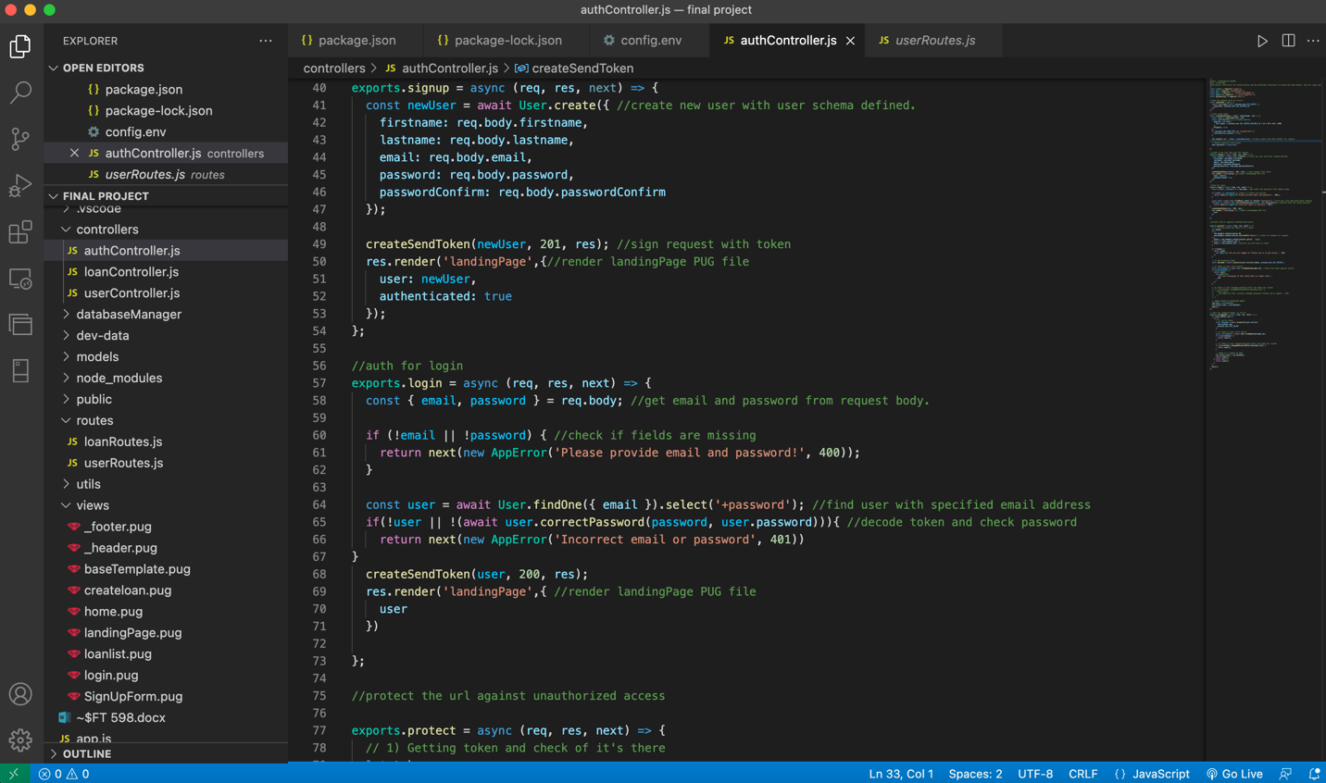

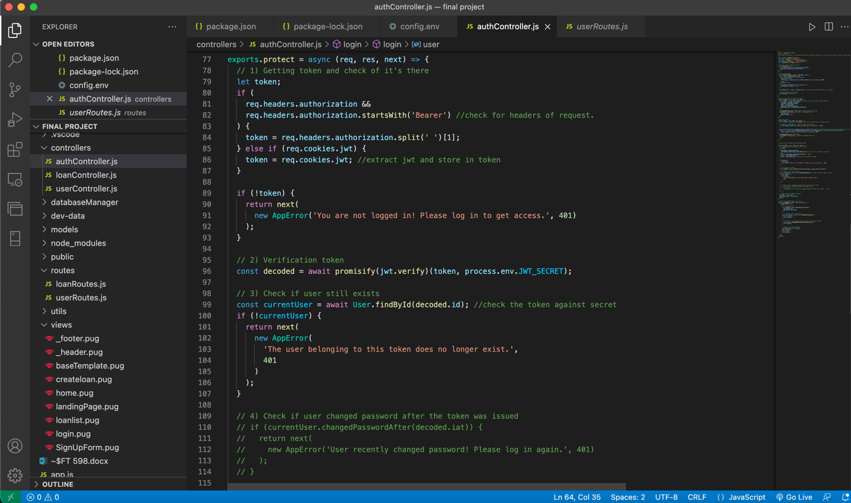

LoanController

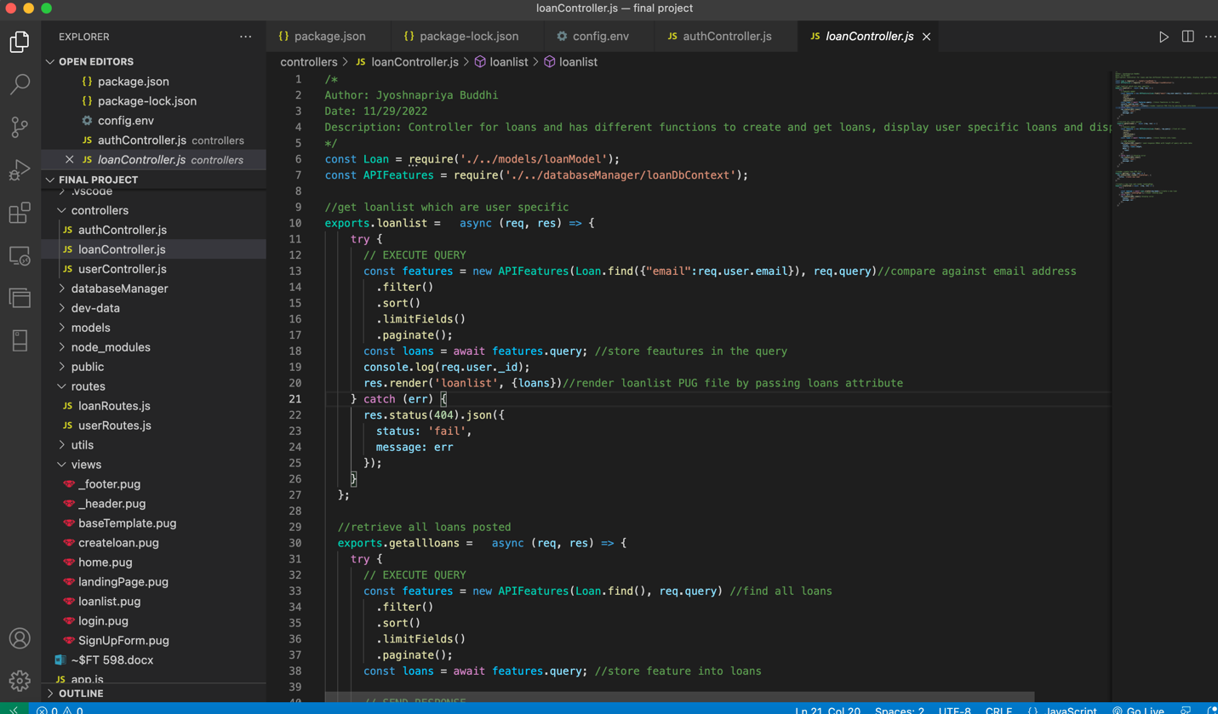

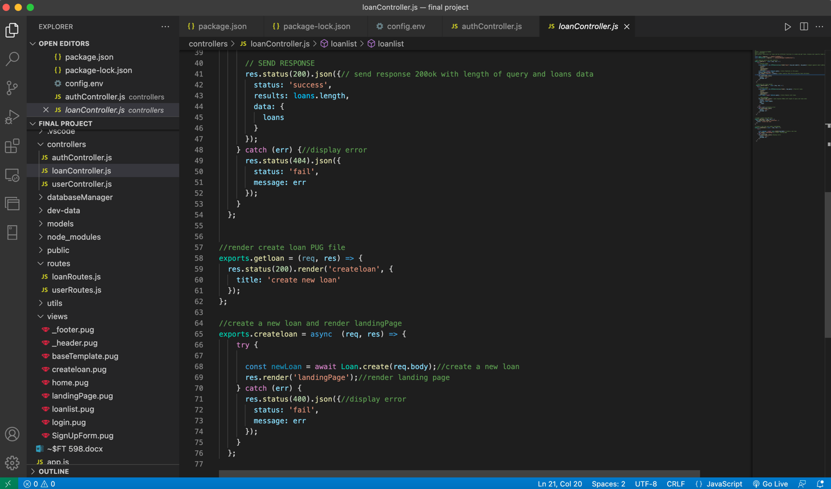

userController

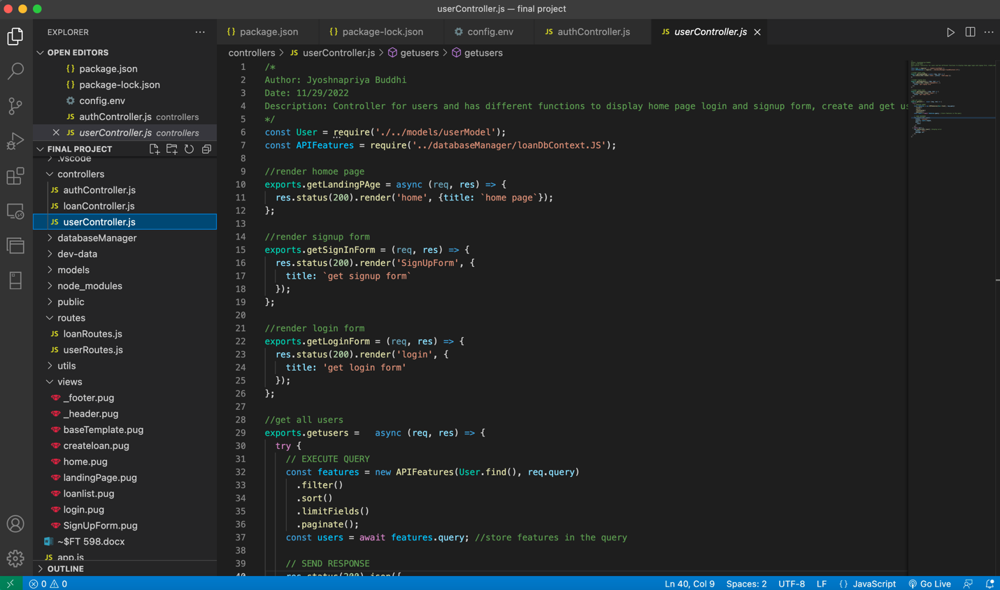

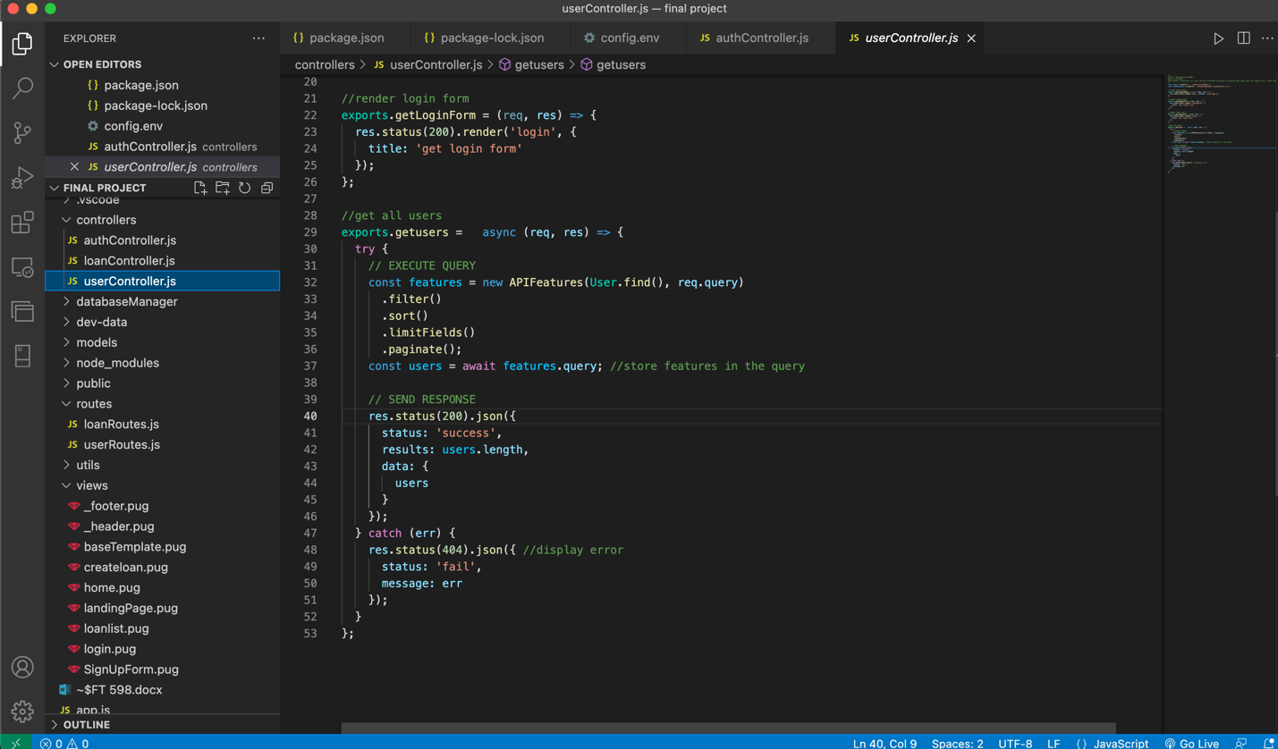

**Flow Diagram for newUser, LoginUser, create Loans and List Loans**

newUser:

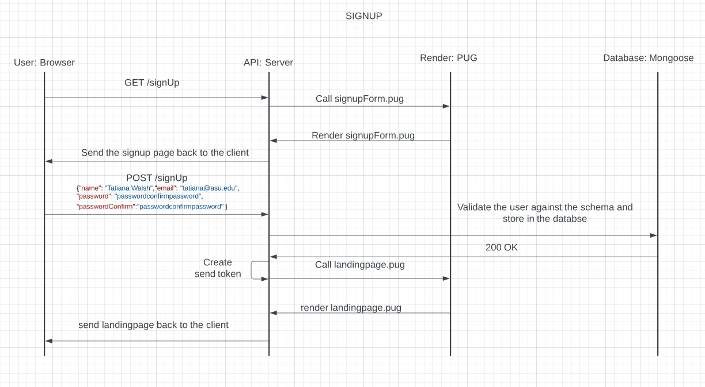

LoginUser

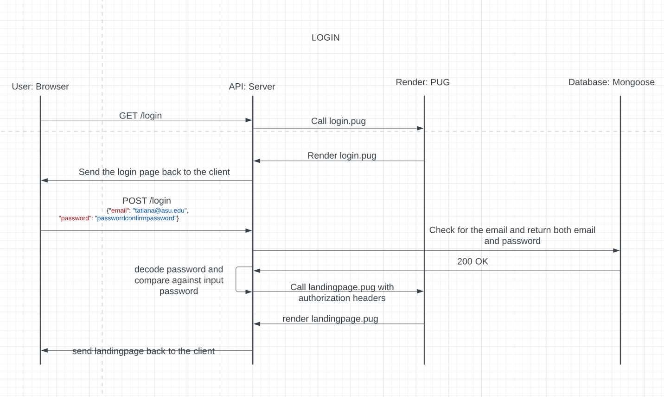

Create Loans

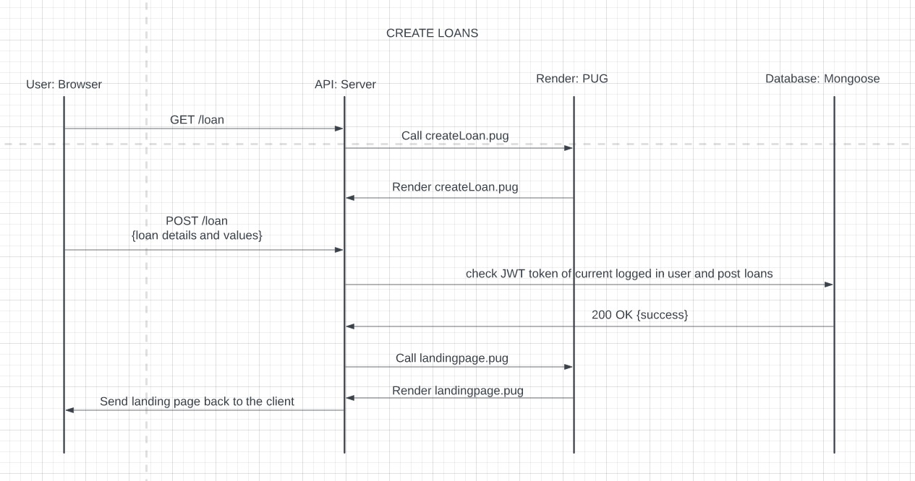

List Loans: 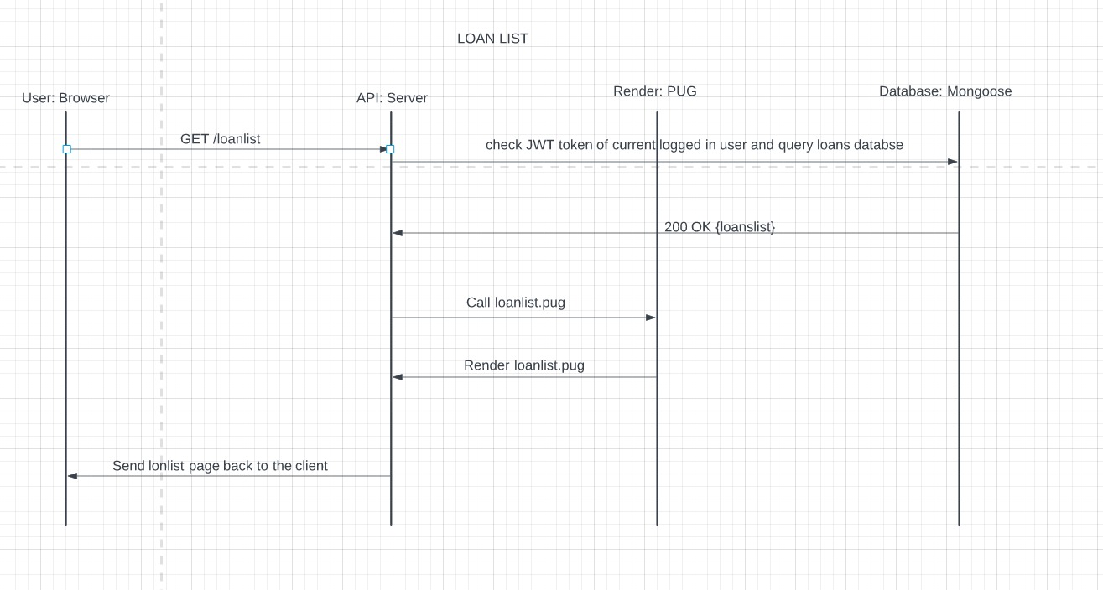

**Data Model with validations for User and Loans**

Loan Model

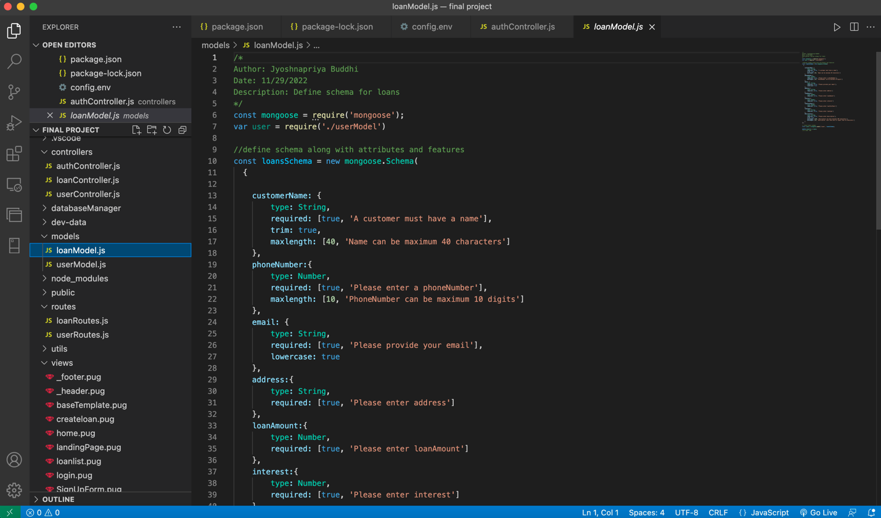

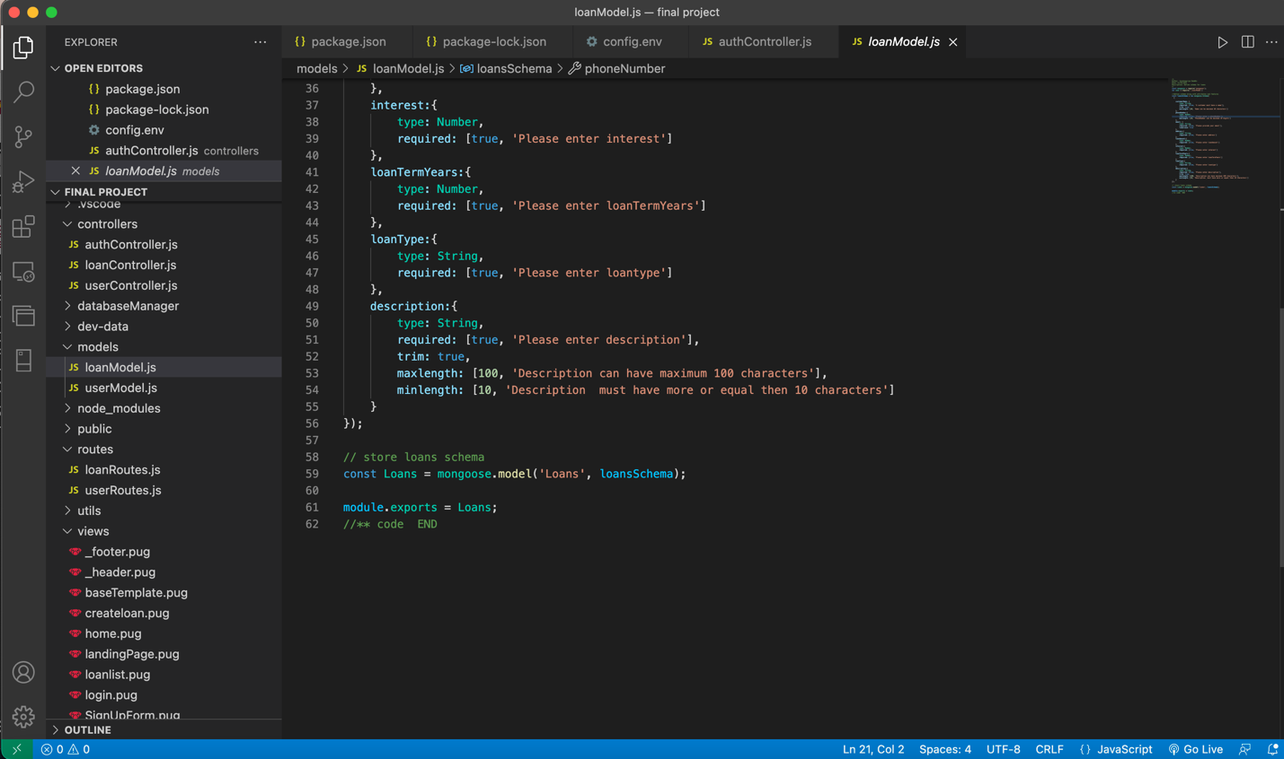

User Model

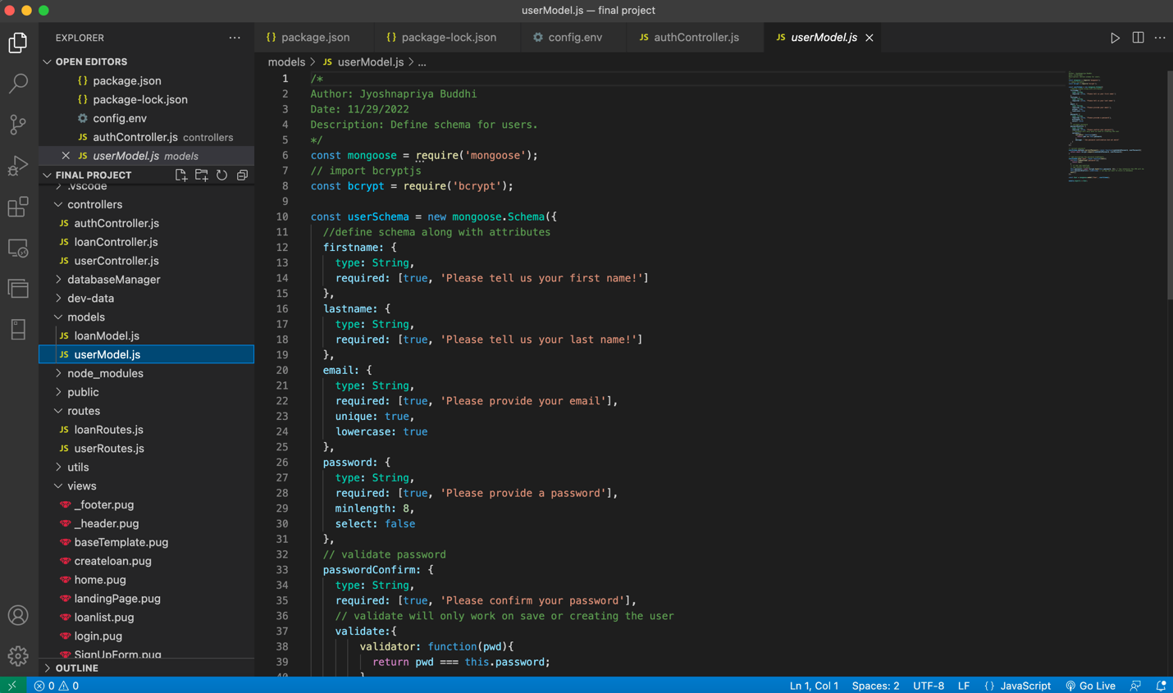

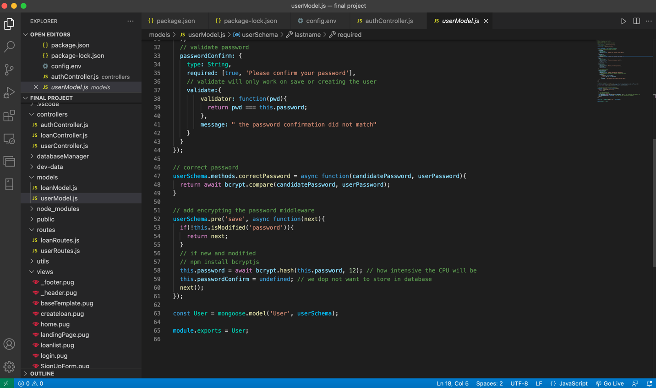

**TESTS: Create POSTMAN test for Create Users, List Users and Create Loans and List Loans**

Create User

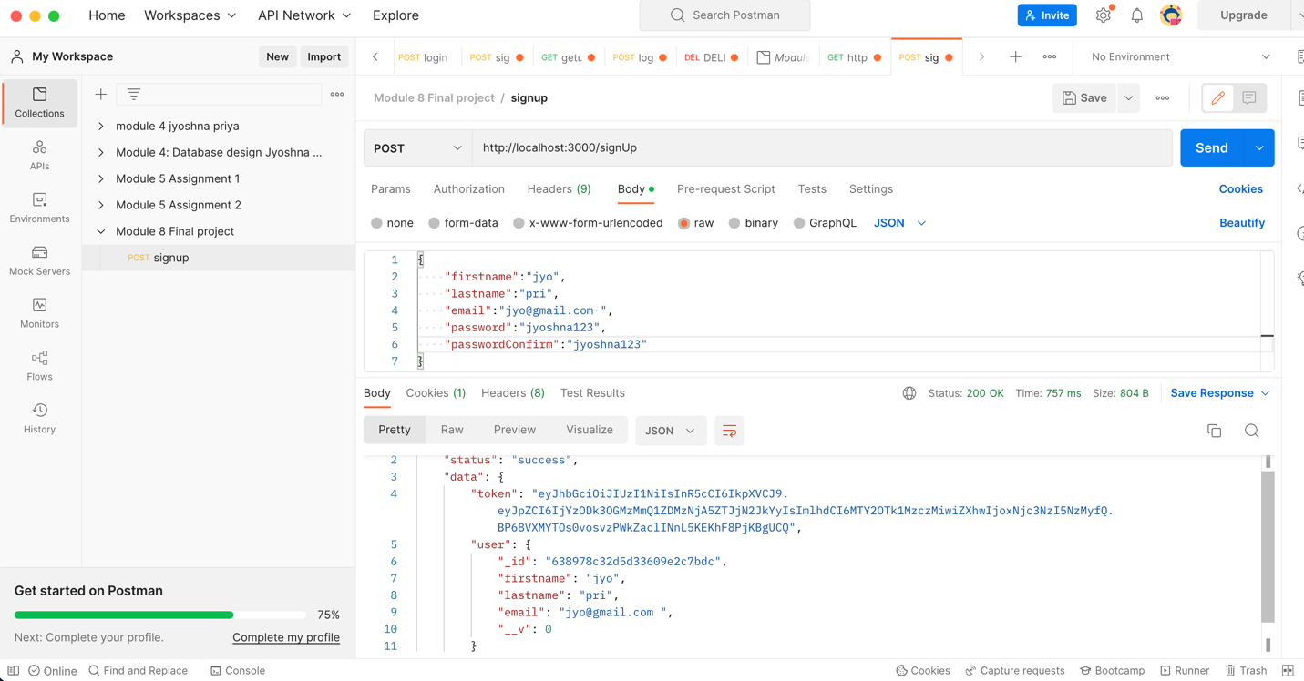

List Users

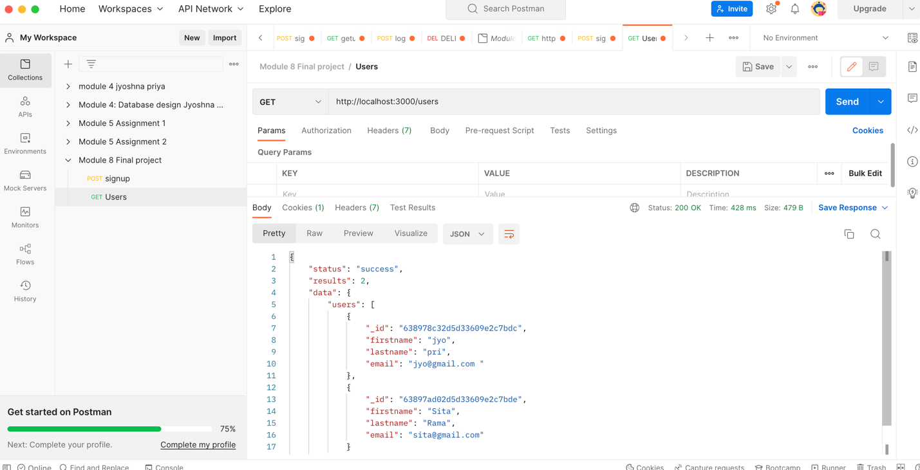

Create loan

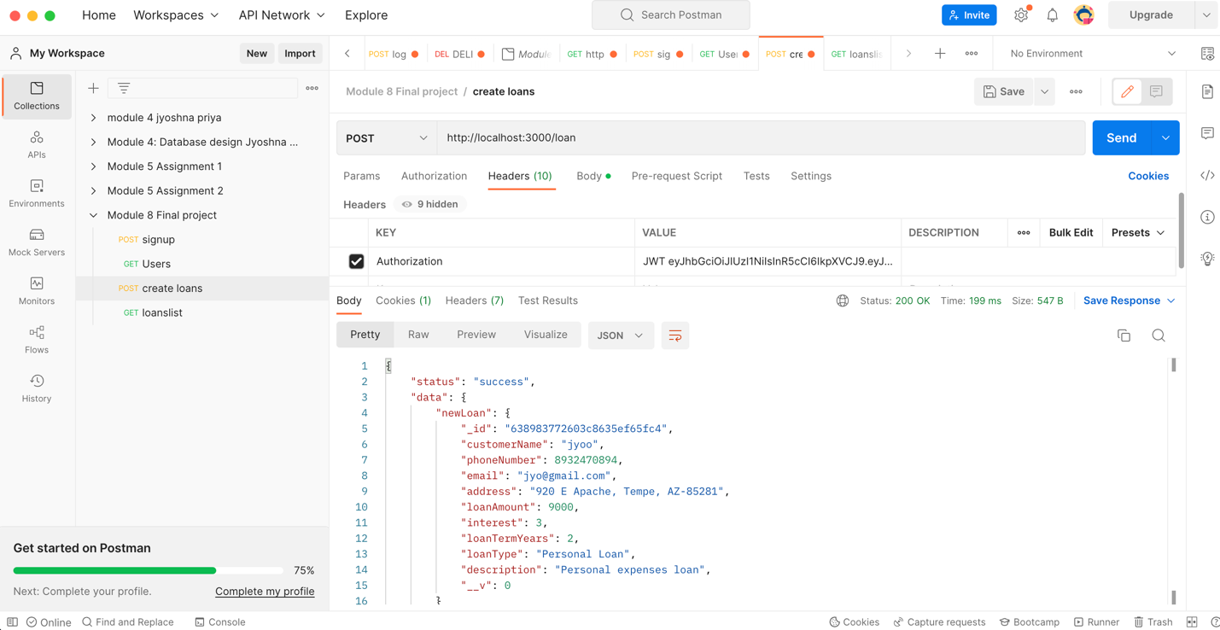

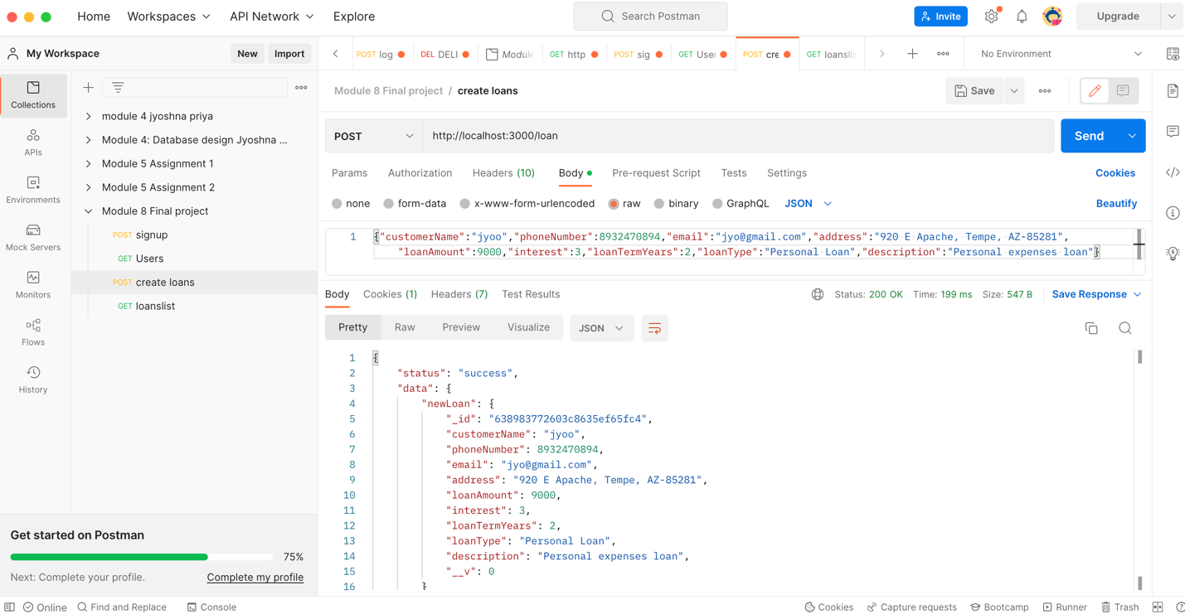

Loanlist

